**DD Unload Information – Bolina Road**

**Welcome to our lovely borough of Lewisham!**

If you know Lewisham, you’ll know this isn’t the most attractive and scenic part of the borough! However, finding space on public highways to manoeuvre and off load hundreds of bikes and riders from large vehicles has got harder and harder over the years. So, we have to take the space we can find. The upside is, cycling links are excellent to other areas of London, and its closer to central London and good transport hubs than many people realise.

The main issue for tired and hungry riders is there are no food venues nearby.

If you need refreshments, nearest café is in Folkestone Gardens Park, almost a mile east along Cycleway 10. Not really possible to use if you arrive before your bike and have to wait a bit.

We will have some croissants and coffee available. First come first served, when its gone, its gone. You can help yourself but please consider leaving a donation: this whole offload is done by volunteers, as is much of the other work Lewisham Cyclists does in the community, and we rely on donations to keep our community work going. We always say donate what you can afford but for at least 2 quid would cover our costs. Anything above that we can put into our funding pot.

Take a look at our website to see what we would do with your donation. Our main aim is to help anyone who wants to cycle to do so, especially those on low incomes. Any surplus we might make from this goes immediately towards funding our Dr Bikes, our Deptford Community Cycle Workshop, and our cycle skills and maintenance training as well as our significant and increasingly effective campaigning.

Portaloos are available. They are under the railway bridge. Remember others will be using them after you. Any issues, please report to one of the offload team.

**Onward travel**

Cycleway 10 is adjacent to Bolina Rd, up the angled ramp. Goes west to Waterloo and east to Greenwich.

Tower Bridge is 2.3 miles (10 minutes). London Bridge is 2.7 miles.

It’s also possible to access C4 from Surrey Quays which also takes you to Tower Bridge, Tooley St and London Bridge

Surrey Quays Overground Station is only 0.7 miles. Useful for getting into N London.

South Bermondsey station is close. Just above us, actually. Up the ramp and on your right. Has infrequent trains to London Bridge and to Peckham and Crystal Palace. Probably quicker and easier to ride to Peckham, its only a couple of miles away.

Map showing route to café, if you do fancy heading there once you’ve got your bike back: just follow C10 marked below.

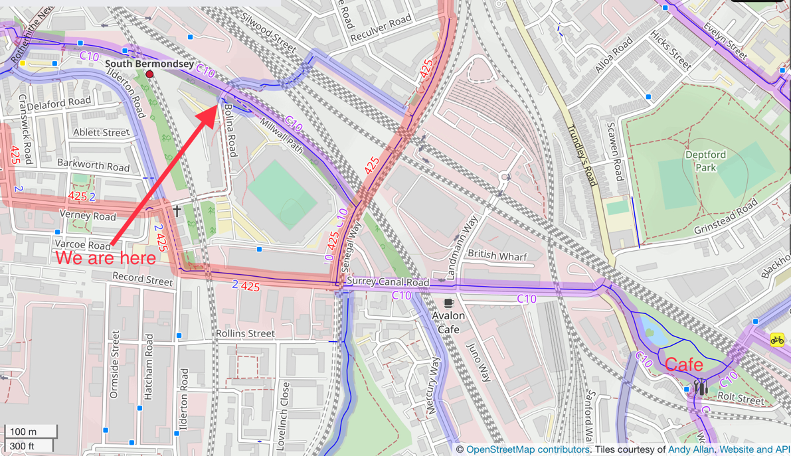

Map of Surrounding Area